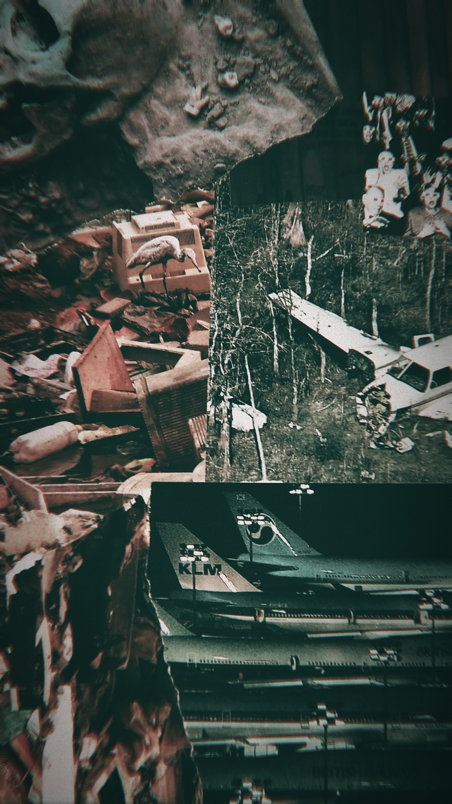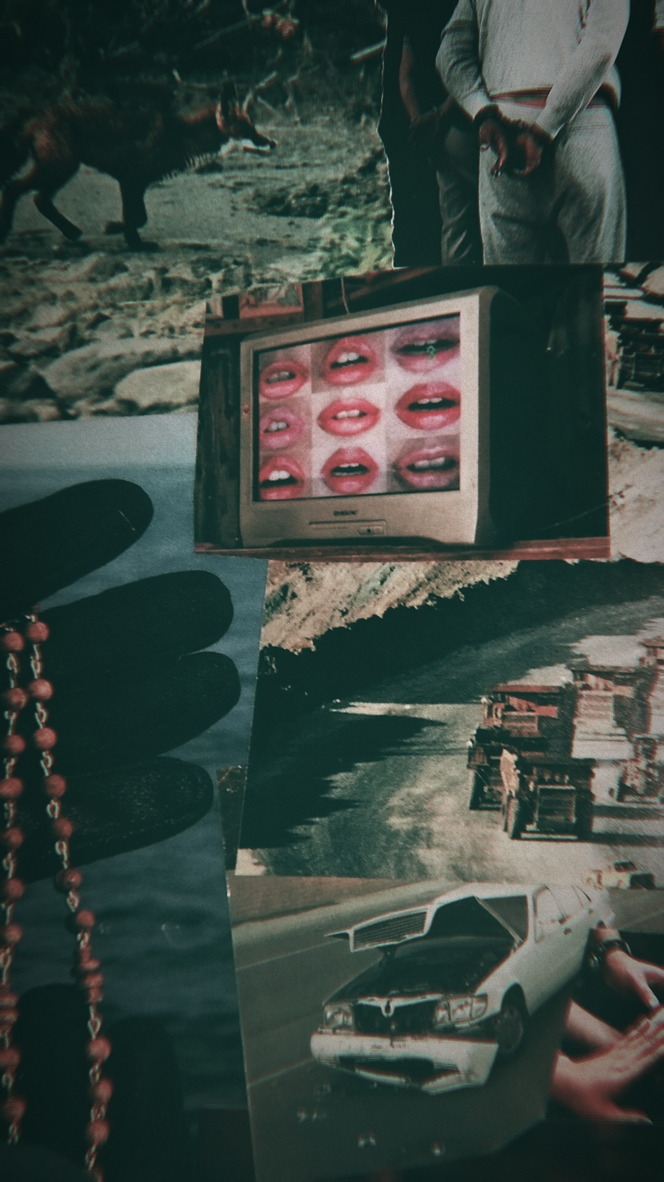

“At What Costs”

1. What is the artist's real name?  
    Sasha Pavlovski
2. Do they have an artist name or alias that they go by?  
    S.P
3. Is there a signature "style" to this artist's work? What kinds of mediums do they use? Do they stick within one medium, or do they continually re-portray the same theme using different mediums? (3+ sentences)

Sasha likes multimedia collage, made out of anything he can get ahold of that speaks to him. He befriended a librarian at a local library that discards dated literature monthly and he is allowed to grab what he might need for his projects, usually magazines, but not always. Sometimes he finds strange things on the ground and finds a way to include it. His artworks often have a somewhat cynical and nihilistic perspective including all the bad parts of history and man made destruction. Some of his works include gory details of raw carnage from war and crime documentations, only noticeable from up close, but easily overlooked at a distance. He occasionally includes quotes or his own poetry with cut out letters from ads, labels, and books. Most of his major works are large scale, but he also carries around a small journal and pastes scraps of things inside as a personal memento.

1. What is the message of this artist? What are they trying to tell the world? Why do they create art?

Sasha would probably shrug if he was asked this personally. His dad is in the russian military so his followers believe his bleak undertones of war and civil unrest have something to do with his upbringing in a strict household. The images he has included in these works all had individual stories that became warped and distorted after he removed them from their original context and gave them a new meaning by throwing them into a completely unrelated work of art. Often times, the things he chooses to include only make sense to him and he refuses to disclose his intention. Whatever the meaning might be is up to the viewer’s interpretation.

1. Where were they born? How old are they now?

He was born in Kaliningrad, Russia but he moved to the UK with his mum for her Job. He is 27 residing in Glasgow, Scotland as of current.

1. What does a day in the life of this person look like? Where do they work, or do they? (3+ sentences)  
    Sasha often wakes up and had breakfast with his mum before leaving to go work at the local antique shop. He occasionally volunteers at the library because of his friendship with the librarian. After work he usually goes to hang with his friends in the basement of their shared townhouse. They go bar hopping on weekends.
2. What kind of a teenager were they? (3+ sentences)

He was a pretty quiet teen, somewhat in denial about his homosexuality for the majority, leaving him pretty defensive in general. He would sometimes lock himself away for hours at a time, occupying himself by reading, writing, and cutting out magazines. He enjoyed history and was a good student. Occasionally, he would walk the town all day and night searching for inspiration. This continued as he got older and met his four best friends, who preferred to wander around in search of fleeting entertainment.

1. What is their dream or goal in life, or what is their idea of a perfect life, or do they have one?

Sasha wants to accept himself and be accepted. He wants people to see his work and simply accept it even if they don’t completely understand it. He wants to move in with his friends. He also wants to buy his mum a nice house nearby and be able to support her so she can retire. He wants someone to hold, which is dangerous because the someone he wants may or may not be one of his close friends who is almost certainly straight. He hopes to die without regrets.

1. What is one of their biggest fears?

He’s afraid of being outed to his dad, or letting his friend know of his crush.

1. What is one of their favorite childhood memories?

Him and his mum making piroshki and dancing in the kitchen before they moved.

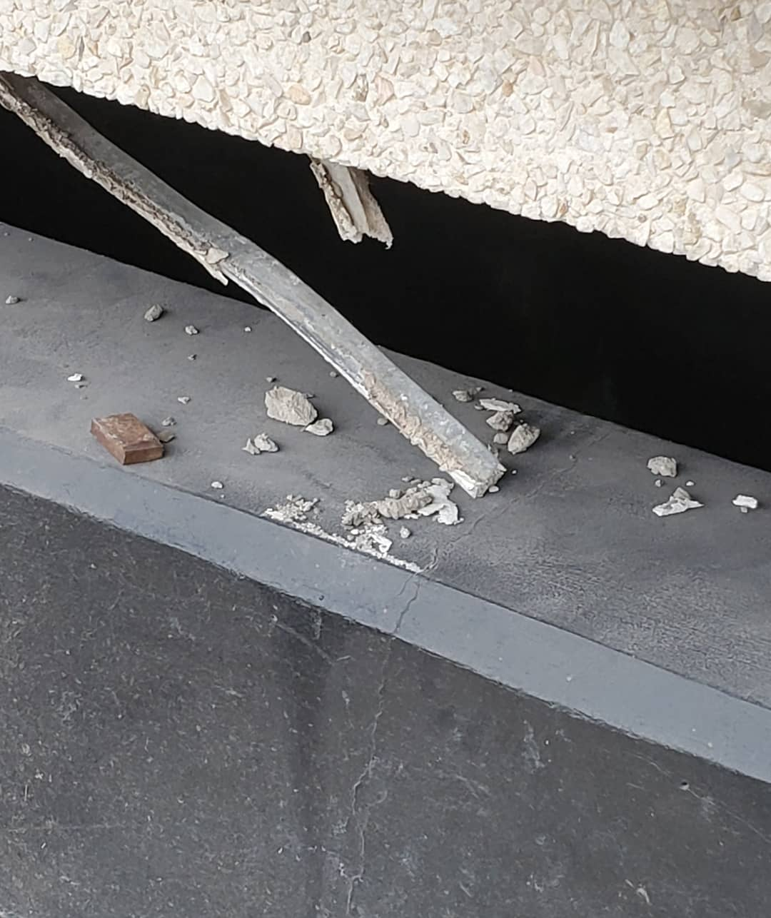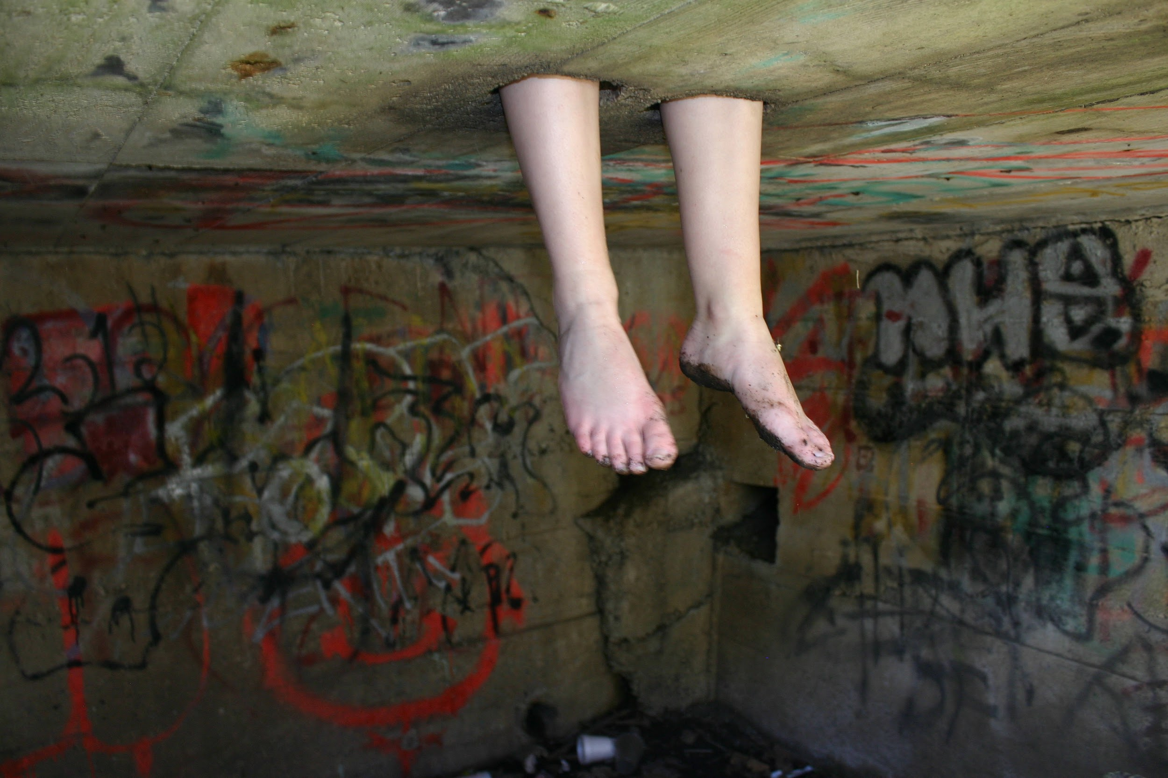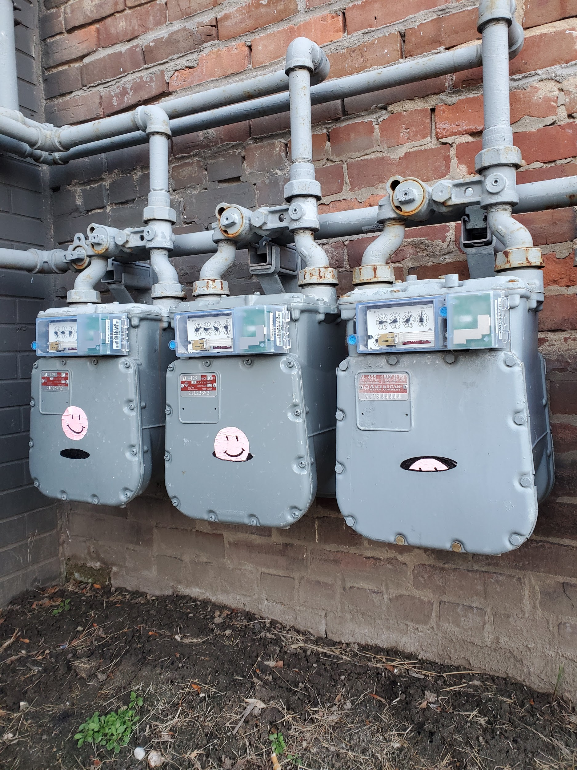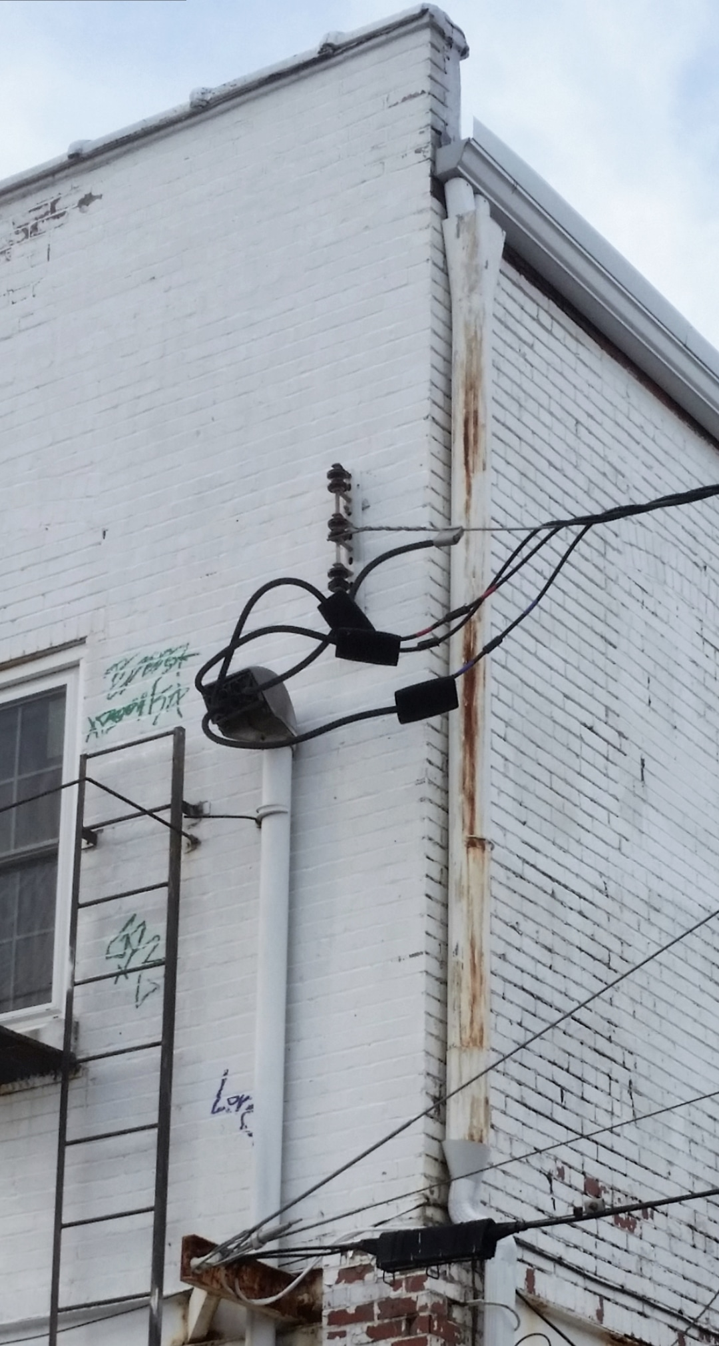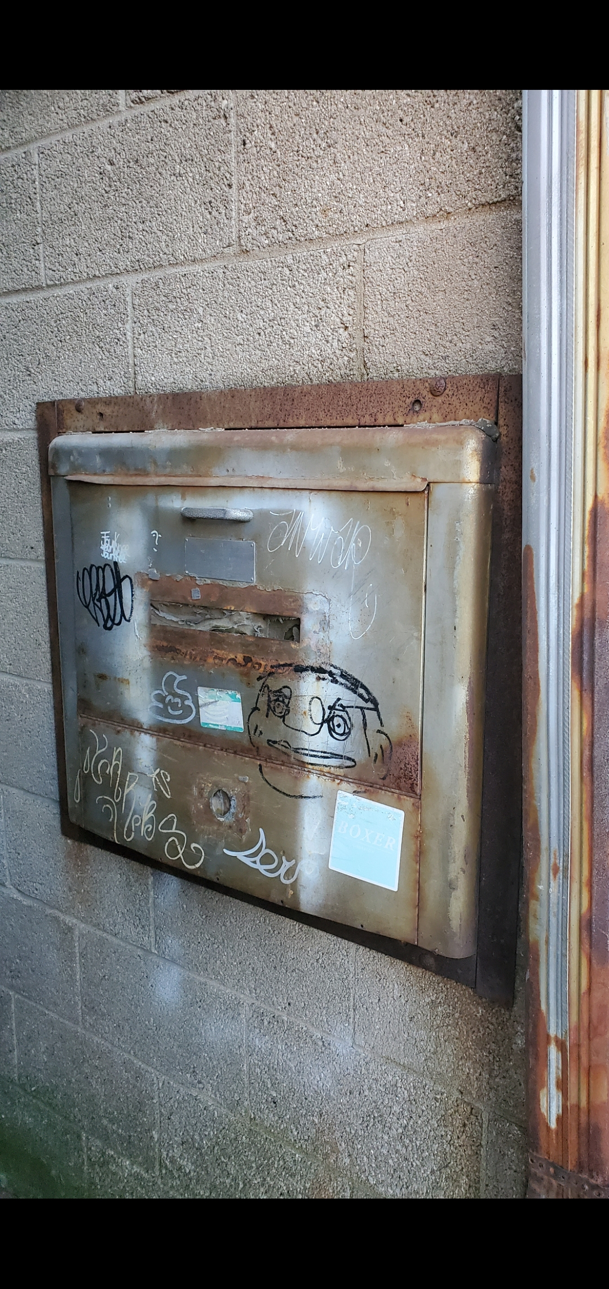

“Concrete Future” Series

1. What is the artist's real name?

Constantine “Connie” Sterling

1. Do they have an artist name or alias that they go by?

Connie S.

1. Is there a signature "style" to this artist's work? What kinds of mediums do they use? Do they stick within one medium, or do they continually re-portray the same theme using different mediums? (3+ sentences)

Connie is a photographer that takes strange shots of abandoned buildings, urban architecture, and dead animals. She is currently working on a series of desolate images that all seem to come from a post apocalyptic city. She calls this collection “The Concrete Future”.

1. What is the message of this artist? What are they trying to tell the world? Why do they create art?

There is no message necessarily, simply a feeling that is conveyed relative to each person that sees the image. She hopes to invoke a sense of loneliness as well as a curiosity for a story that is only told in pictures she provides. Connie started taking photos on her walk home from school every day because she passed by several things that intrigued her, like an old warehouse, an abandoned church, a dead bird, and she felt like she was the only one who acknowledged these forgotten objects that were once full of life and wanted to share their beauty as they slowly decayed. She extended her focus to all forms of things that she went by on a regular basis, like local street art, litter in the medians, broken windows, back alleyways ect.

1. Where were they born? How old are they now?

Connie was born in Minneapolis, Minnesota. She lives there today having just graduated as a photography major from the U of M at 23

1. What does a day in the life of this person look like? Where do they work, or do they? (3+ sentences)

Connie works at the art museum and is currently working on finding a studio for her freelance photography work so she can eventually do photography full time. She lives in an old dated apartment less than a mile off campus and commutes to work every morning. She has felt slightly lost since she graduated.

1. What kind of a teenager were they? (3+ sentences)

Connie was a really creepy teenager that took her camera everywhere. She kept getting in trouble with the cops for trespassing but they always let her off because she looked so innocent. It’s a miracle she never got hurt or kidnapped. She also loved to draw.

1. What is their dream or goal in life, or what is their idea of a perfect life, or do they have one?

She wants to own a Studio and run her own business. She would like to have a significant other and maybe get a dog. She doesn't particularly want to get married or raise kids, but if she did, she would wait until she was like 40.

1. What is one of their biggest fears?

She is literally afraid of nothing. It’s kind of unsettling.

1. What is one of their favorite childhood memories?

She found an old crick that ran from a drainage pipe near a path through the forest she used to walk. She would go down there and catch frogs and climb trees and pretend she was the only one in the world. It was her favorite spot.

1. What is the artist's real name?

Emilio Jean Marcelos

1. Do they have an artist name or alias that they go by?

Emilio Jean

1. Is there a signature "style" to this artist's work? What kinds of mediums do they use? Do they stick within one medium, or do they continually re-portray the same theme using different mediums? (3+ sentences)

Emilio makes a ton of different works with several mediums including film, oil paint, and music. He often records his progress when he paints. If he makes films he records audio of songs he wrote that he sings with his guitar plays on the piano at his mom’s cafe. His oil paint works are very elegant with ignudi figures depicted in situations of everyday life and untouched nature scenery. Brighter primary colors are used for emphasis on more pastel backgrounds. His brush strokes are visible in a manner similar to Claude Monet and Vincent Van Gogh.

1. What is the message of this artist? What are they trying to tell the world? Why do they create art?

He stresses innocence, sensuality, and the natural human body, without the common sexual undertones of other artists of his kind. He considers himself a hopeless romantic focusing on the individual’s personality based on the context in which they are painted instead of the physical body they inhabit. He shows scenes of platonic relationships between figures and domestic romance of individuals in love of all shapes, sizes, colors, and gender. His subjects are unique and sometimes blur the lines of stereotypes with characteristics traditional of the opposite sex because he believes it is important to acknowledge that biological sex and gender are to be respected as seperate entities when social constructs are removed. He grew up with his mom, had long hair, and lots of friends who were girls. Since he was born he always liked more supposedly feminine things such as cute animals, flowers, fashion, color, decoration, softness, and personal hygiene. These concepts often show up as details in his art. He still considers himself very much a male who isn’t concerned with other people's ideas of what he should be. His mother never pressed masculinity onto him and he trusts her for that. She shows up in his art often as well because of his respect for her as the ideal maternal figure.

1. Where were they born? How old are they now?

He was born in Barcelona, Spain, lived there his whole life with his mom in the apartment above his mother’s coffeeshop. He is 20.

1. What does a day in the life of this person look like? Where do they work, or do they? (3+ sentences)

He wakes up and immediately goes downstairs to help his mother open shop, he works there to help pay rent. He often entertains the customers with his fancy mixing skills when making drinks, and practices piano on his breaks, collecting tips for his art. When he is done he goes to the top floor of their apartment to the sunroom to paint where there is plenty of ventilation when the windows are open. He likes being able to see over the balcony and be surrounded by their potted plants. When he finishes a painting, his mom will display them somewhere in the shop. The regulars often ask to see more and sometimes will buy them. He takes whatever they offer and never asks for more.

1. What kind of a teenager were they? (3+ sentences)

Emilio has always been a very kind and respectful boy, growing up to be a gentleman and a hard worker. He often got called a pretty boy in both good and bad context. He has been beaten up twice, but he didn’t let that make him mean. He was mostly unphased by the bullies knowing they were probably jealous or had bad home lives. They usually left him alone when he didn’t react or retaliate. He has dated both guys and girls, but he’s more interested in his art. He figured “the one” will find their way to him no matter what. Many of the regulars at the shop have gotten to watch him grow up and the old ladies love him, fawning over him as if he was still a little kid, but he doesn't mind.

1. What is their dream or goal in life, or what is their idea of a perfect life, or do they have one?

He wants to keep the shop in business for as long as possible and decided he would take over when his mother can no longer do such strenuous work. He would love to get married and have kids so he can paint them as a family. He pictures living in a small cottage outside of town on a nice plot of land surrounded by forest and a beautiful garden.

1. What is one of their biggest fears?

Losing the Cafe or accidently killing his mom's plants.

1. What is one of their favorite childhood memories?

He has a very vivid memory of his mom teaching him to play the piano and singing to him in front of the cafe before its grand opening later that day. Any time where he gets to spend time with his mom is always a fond memory.